Terms of Reference

Name: | Care Capacity Demand Management Council
Author: | CCDM Council | Date: | 03/02/17
Tenure: | Permanent | Reviewed | 21/11/2018
 |  | Review Due | 15/07/2021
 |  | Updated (membership only) | 15/06/2021

Title

Care Capacity Demand Management (CCDM) Council
The Council was established in February 2017 as per the first date of the terms of reference.

Purpose Statement

Together we successfully lead and sustain the Care Capacity Demand Management (CCDM) programme to ensure safe staffing, healthy workplaces and achieve better healthcare consumer* outcomes.

*Healthcare consumer – any actual or potential recipient of healthcare, such as a patient, a woman in a maternity setting or a client in a mental health setting.

Objectives

The CCDM Council is a permanent structure that governs organisation wide decision making for care capacity and demand management. The Council ensures safe staffing and healthy workplaces by:
- Overseeing the implementation of the CCDM programme in a timely manner.
- Ongoing monitoring of how well the DHB is performing at matching demand with capacity in the moment and over time.

Reporting Structure

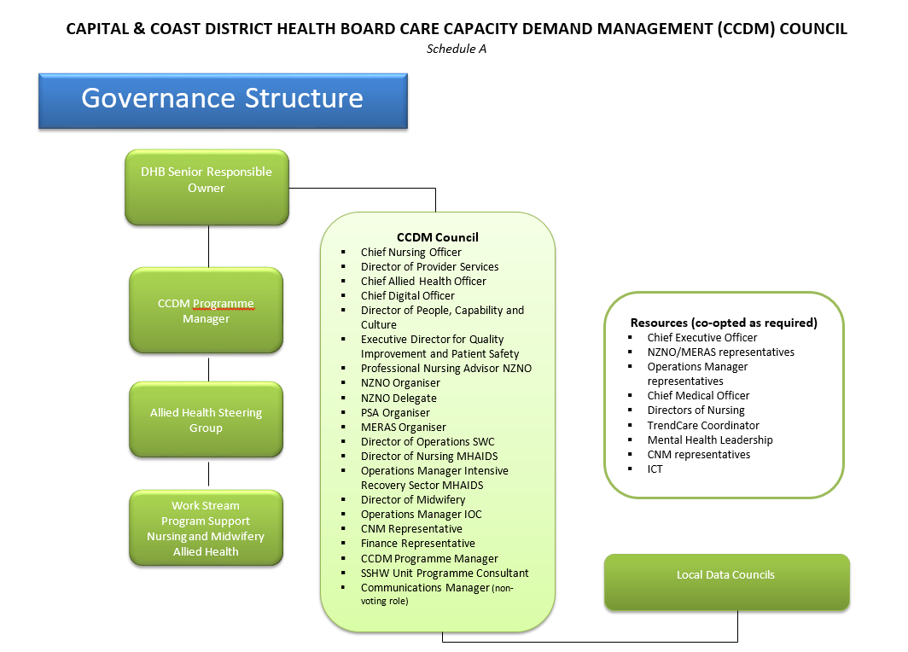

Key Tasks/Role

- Develop and maintain a work plan for programme implementation.
- Assign and review roles, responsibilities and timelines for implementation.
- Monitor and evaluate the progress of the CCDM work programme.
- Provide resources and remove barriers to programme implementation.
- Deploy effective change management processes in accordance with MECA agreements.
- Support and develop internal expertise in care capacity demand management at all levels of the organisation.
- Ensure partnership processes and practices are managed effectively in accordance with the CCDHB CCDM Partnership Charter and Frame work (Appendix 1).
- Support the CCDM Programme Management team to be effective and successful in their roles by taking responsibility and accountability for programme direction and decision making.
- Report to Chief Executive on programme implementation progress and care capacity demand management outcomes.
- Communicate with all key stakeholders on progress.
- Establish and maintain local data councils and their reporting framework.
- Establish and monitor core data set reporting.
- Act on findings from staffing methodology.
- Make decisions in a timely manner to ensure effective care capacity demand management.

Membership (Schedule A)
2020/21 membership as of the 15/06/2021
Name | Role
Chris Kerr | Chief Nursing Officer 2DHB
Joy Farley | Director of Provider Services 2DHB
Chris King | Chief Allied Health Officer 2DHB
Brigitta Duncan | ICT Portfolio Manager 2DHB
Stephen Burrage | Principal Advisor – relationships, Policy & Reward 2DHB
Suzanne Rolls  Jo Coffey  Alex Ward  Caroline Conroy | Professional Nursing Advisor NZNO  NZNO Organiser  PSA Organiser  MERAS Organiser
Annie McCabe | NZNO Delegate
Gina Lomax | Group Manager Hospital Flow
Kym Park | Director of Nursing MHAIDS 3DHB
Tony Littlejohns | Operations Manager Intensive Recovery Sector MHAIDS
Carolyn Coles | Director of Midwifery (DOM)
Kaye Hudson | Operations Manager IOC
Lisa MacDonald | CNM representative
Matthew Whitehead | Business Services Manager Corporate and Executive
Emma Williams | CCDM Programme Manager
Stuart Port | SSHW Unit Programme Consultant
TBC | Communications (non-voting role)

Responsibilities

- Group members are expected to attend and participate in all meetings.
- Where members are unable to attend a meeting proxy will not be accepted.
- Members are to inform the Chairperson by apology if not attending a meeting.
- Other members may be co-opted to the CCDM Council as and when required to provide expert advice.
- Members shall inform the Council of any changes in contact details.
- Abide by the decisions of the Council.
- Ensure confidentiality of information provided to the Council.
- Discuss and disseminate information and liaise with the people/groups the Committee Member is representing.
- Communicate relevant issues to the Chair for the agenda, prior to the agenda closing date.
- Provide feedback on all documents received and ensure that monthly action sheet requirements are followed through and reported on in the time frame agreed to.

Meeting Process

Meetings will be held on a monthly basis - the 3rd Wednesday of each month from 2.00 – 4.00pm.

A quorum for a meeting is represented by a 50 percent attendance of the group plus the chair. This must include union representation and a CCDHB decision maker (Chief Executive; Executive Directors). Should the quorum not be present, items passed will be held for ratification until the next meeting.

- An agenda and papers will be circulated by the CCDM Council Chair / co-chairs or designated other (such as a Personal Assistant) at least 1 week before meetings.
- Additional agenda items may be taken by the chair/ co-chairs at the meeting or prior to teleconference commencing.
- Minutes of meetings in summary form including action points and recommendations will be recorded and circulated by seven days after the meeting as a record of meeting and action points or tasks to be undertaken.
- Members of the group who attended the meeting will be provided with five working days to comment back on the minutes requesting additions or amendments.
- Minutes shall then be distributed to members but have no status until confirmed at next scheduled meeting/teleconference. They may be amended before confirmation. Copies will be retained as part of the CCDM Council - Programme documents.
- Members will be requested to feedback and comment on key programme documents and will be provided with five working days to do so.
- Should a member write to the Chairperson and request to resign, consultation shall occur within the Council prior to the election of another member.

Decision Making

- Where possible, decisions will be made by consensus.
- If group consensus cannot be reached a summary of views will be documented, distributed and held within the group document file.
- Where decisions are contentious and/or complex, a decision making framework will be used and separate detailed documentation made on the Decision Making Record.

Functional Relationships

Examples include (but are not limited to):
Integrated Operation Centre * Add consensus guidelines
Quality Committees/ICT
Medical teams/MDT
Communications

Associated Documents
SSHW Unit Decision Making Framework
SSHW Unit Decision Making Record
CCDHB Delegation Document

Appendix 1
Partnership Charter: Care Capacity Demand Management (CCDM)

This charter is a living document. Amendments to this charter can be proposed at any time by any member of the Capital & Coast DHB CCDM Council. Any changes will be agreed by consensus.
This is an agreed foundation document and an agreed way of working for the CCDM programme.

Partnership:
Workplace partnership is about active relationships between unions and the employer where they are working cooperatively and jointly to address areas of mutual interest.

Collaboration is at the heart of partnership.

Purpose Statement:
Together we successfully lead and sustain the Care Capacity Demand Management (CCDM) programme to ensure safe staffing, healthy workplaces and achieve better healthcare consumer* outcomes.

*Healthcare consumer – any actual or potential recipient of healthcare, such as a patient, a woman in a maternity setting or a client in a mental health setting.

Goals:
By April 2018
All participants will be fully operating in the partnership framework.

By October 2018
The partnership framework is fully embedded in all of our work.

Leadership
Co-leads - Responsibility is shared between the CCDM partners.

During Council discussions, group members can put forward and explore ideas and proposals without necessarily committing to them. The principle is that the parties can discuss an issue and not be bound to any ideas, information or proposed solutions until there is an agreement made by consensus

Core principles that underpin how this Council will work
- Accountability to partnership process
- Respect for difference and separate needs
- Tangible, valued, substantive results
- Transparency
- Focus on mutual benefit
- Strong champions
- Refer to ‘partnership framework’ and ‘partnership best practice’ pyramid

Meeting Process:
Start of each meeting:
- Co-leads or project champion open the day
- Establish if there is a quorum for decision making
- Confirm the purpose and agenda for the meeting
- Check for any questions regarding the meeting
- Confirm roles and timeframes for the meeting
- Check progress/completion of agreed actions from previous meeting

Close of each meeting:
- Check against ‘partnership framework’
- Agreed next steps and action points
- What is confidential from today?
- Agree what is communicated to the wider group and how that will be done
- Agree what notes need to be electronically recorded and who will do that
- Assign roles for the next meeting
- Form the basis of the next meeting’s agenda
- Review of how the group interacted in terms of partnership principles

Roles within each meeting:
- Facilitator
- Recorder (during the meeting and for electronic record)
- Time keeper
- Group member

Caucusing
Either of the parties can call for caucus at any time if they feel it is useful to do so. A caucus call cannot be refused.

Decision Making
- At the start of any discussion both parties will clarify this Council’s decision making mandate.
- That mandate may be for a full decision or for a recommendation.
- Decisions and recommendations are made through the consensus process.
- During discussions it may be useful to do the ‘thumbs’ climate test to identify where there may be difference.
- Before decisions or recommendations are made they should be tested against the interests.
- As a consensus decision is made all participants articulate their agreement (or non-agreement in which case discussion continues).
- If the Council is ‘stuck’:
  - Understand where we are stuck
- Test against the interests matrix
- Is more information needed?
- Would other options work?
- Could it be ‘good to go’?
- Get a neutral third party involved to test our thinking and facilitate progress.
- Consensus is where I can actively champion a decision, even if it wasn’t my first choice.

Resolution of Issues/Dealing with Disagreement
- The parties will undertake this work using partnership values and processes such as active listening, consensus decision making and interest based problem solving.
- However, nothing in this charter precludes any party from choosing to exercise its traditional and legal rights at any point.
- If this CCDM Council cannot reach consensus, it will seek guidance from its union and management leaders. As part of this process this Council will summarise the options under consideration with a rationale for each.

Dealing with Contractual Issues
This CCDM Council has no mandate to make any contractual changes. If it identifies a recommendation that may have contractual implications these should be highlighted.

Communications
- This Council will develop a communications strategy regarding the work it is undertaking.
- The Council recognises the important link between communications and engagement.
- The Council members will communicate with its stakeholders regularly and agree the key messages to be communicated.

Confidentiality
- Any documentation or information or discussion that is expected to be held in confidence will be identified prior to its sharing.
- At the end of each meeting the question will be asked, “What is confidential from today?".

